Role of MgSO₄ and mixing efficiency in oxygen delignification of cellulosic pulp
Background
Oxygen delignification (OD) is a key process in modern kraft pulp bleaching, enabling significant lignin removal while reducing the consumption of chlorine-based chemicals. However, OD is often accompanied by undesirable cellulose degradation due to radical-driven reactions catalyzed by transition metals. Magnesium sulfate (MgSO₄) is widely used as a protective additive to improve carbohydrate preservation, yet its effectiveness is strongly influenced by process conditions such as metal content and mixing efficiency. Despite industrial use, the combined influence of MgSO₄ dosage and mixing quality on OD selectivity is not fully understood, particularly at mill-relevant conditions.

Objectives
The main objective of this research is to evaluate the effect of MgSO₄ addition and mixing efficiency on delignification performance and cellulose preservation during oxygen delignification. Specific objectives are:
1. To study the influence of MgSO₄ dosage on kappa number reduction, ISO and pulp viscosity.
2. To assess how mixing intensity affects oxygen delignification selectivity.
3. To analyze the interaction between MgSO₄ distribution and metal-catalyzed carbohydrate degradation.

Methodology
Laboratory-scale OD experiments will be conducted using industrial kraft pulp. The experiments will be performed at controlled temperature, alkali charge, oxygen pressure, and consistency in Parr reactor at BPTI, TU Graz. Different MgSO₄ dosages will be applied, and mixing conditions will be varied using controlled agitation speeds or mixing devices. Pulp samples will be analyzed for kappa number, intrinsic viscosity, (possibly pulp yield), and metal content (ICP-OES). The results will be statistically evaluated to determine the significance of MgSO₄ and mixing effects.

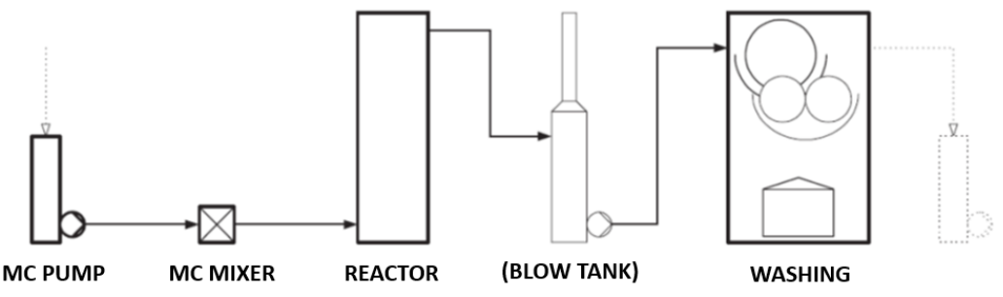

Industrial partner: Mondi AG, Marxergasse 4A, 1030 Vienna (www.mondigroup.com)
Research partner: Graz University of Technology
Type of thesis: Master Thesis, English language is preferred AND female students
Start date: Any time between April 2026 and Jan 2027
Place of work: Graz
Supervisors: Grigory Zinovyev, PhD Email: grigory.zinovyev@mondigroup.com
Salary: Yes, please ask for details

